Rutta Kidane

National University:  9888 Lightwave Ave, SanDiego, CA

The NEMT Project

IT Implementation Plan

**Table Content**

**Topics**  **pages**

**Executive Summary …………………………………………………………………………....3**

**1. Business Need Assessment and Requirements Analysis with SWOT…………………….4**

**1.2 SWOT Analysis of NEMT project…………………………………………………….5**

## **1.2.1 Strength…………………………………………………………………………….6**

**1.2.2 Weakness…………………………………………………………………………...7**

**1.2.3 Opportunities………………………………………………………………………7**

**1.2. 4 Threats…………………………………………………………………………….7**

**2. Project Work Plan……………………………………………………………………………8**

**2.1 Tasks and Schedules……………………………………………………………………. 8**

**2. 2 User Case Data Structure………………………………………………………………10**

**3. Measuring and Reporting Team performance and Project progress……………………12**

**3. Measuring and Reporting Team Performance and Project Progress………………. .14**

**4. Risk Reduction Strategy…………………………………………………………………….17**

**4. 1 NEMT Project Risk Management Risk Matrix ……………………………………...18**

**4. 2 NEMT Project Risk Management Risk Registry……………………………………...19**

**4. 3 The NEMT Project Risks Mitigation Techniques and Legal Measures……………...19**

**4.3.1 Security Risk……………………………………………………………………….20**

**4.3.2 Technical Risks…………………………………………………………………….21**

**4.4 Legal Consideration in NEMT Project…………………………………………………...21**

**5. IT Support program in the Healthcare Technology Company…………………………….22**

**5.1 IT Support -Level 0………………………………………………………………….22**

**5.2 IT Support-Level 1……………………………………………………………………22**

**5.3 IT Support-Level 2…………………………………………………………………... 23**

**5.4 IT Support-Level 3- …………………………………………………………………...23**

**5.5 IT Support- Level 4- …………………………………………………………………...24**

**Conclusion.…………………………………………………………………………………………...25**

**References- …………………………………………………………………………………………...26**

**Executive Summary**

The Healthcare technology company software development team based in Denver; Colorado proposed a new project to create a Non-Emergency Medical Transportation(NEMT) User Interface Software. Non-Emergency Medical Transportation (NEMT) was only used by the driver’s transport agencies and the client could not easily book trips and had difficulties reaching medical care destinations. The healthcare company as its continuous effort in making health care accessible to communities, especially to underserved communities has developed a new additional system product to existing products of remote patient care, and personal care IT solutions and a refinement project to the Non-Emergency Medical Transportation Driver Interface Software (Modicare, 2023).

The user interface of NEMT has similar functionality and features to the Uber user interface. As Addivice (2023) describes Uber user interface functionality and features, the NEMT user interface app has features such as register, login, booking, select car type, insert location, insert destiny, ride tracking, messaging, calling, book for later, cancel the trip, rate the trip and more. Using the app clients can be able to sign up to open a ride account, sign in to access the app, book a ride, select the type of car, insert pick up and destiny location, track the ride, call, or message customer services, cancel the ride, book a ride for later and rate the trip experiences.

The NEMT project team believes a carefully designed software development work plan and good coordination of human and technical resources achieve a sound system solution. Thus, the team coordinates standardized techniques, methodologies, and tools to plan, design, develop, implement, deploy, and maintain the proposed system solutions. These include business need assessment, requirement analysis, resource allocation techniques, IT solution design, IT support services, business continuity plans, and ethical considerations.

**1. Business Need Assessment and Requirements Analysis with SWOT**

The newly proposed system solution will be a valuable tool for clients by giving efficiency, ease, and time effectiveness noted by Modivcare (2023). Before, clients had called the transport company to request medical transportation and sometimes waited for a long time to get responses. The transport service was not flexible enough to provide services whenever clients wanted, and wherever they were located, since clients could not access the service system at any point in time they wanted. It was hard to track the requested ride, cancel the ride, schedule the ride for later, or rate their own trip experiences because they had to call or contact the transport company and wait for the responses all over again as well.

As Modivcare(2023) stated the NEMT will add a substantial merit in extending client experiences to the best. Client will access the medical transport service 24/7 by just downloading the app and able to reach their destination to any medical appointment place whenever they want to. Using the app , not only client get transport service, but also have a contact to live care services with multiple level of support in time of emergency or disaster. With innovative technology in using Geo-location and SMS notification system , the newly developing system solution also be a user-friendly platform to supplement a reliable and safe medical and social trip.

The NEMT user interface will be developed in the form of mobile application, web portals , and interactive voice response(IVR) that allows clients to access the services from different platforms. The NEMT will be created using programming languages of JAVA, PHP, HTML, and Swift, and SQL programming languages to write the program. To optimize the performance in smartphones, Mobile app development frameworks such as Native app and web native mobile apps will be implemented. Furthermore, to boost network and minimize errors Mobile commerce, Artificial Intelligence(AI) and 5G Technology will be utilized (Fingent, n.d.).

**1.2 SWOT Analysis of NEMT project**

According to Wikipedia(2023) SWOT analysis is an approach for strategic planning helps to identify strength, weakness, opportunities, and threats to achieve the desired goal.

**Table 1**

*SWOT Analysis of NEMT project*

|  |  |
| --- | --- |
| **Strength** | **Weakness** |
| ● A precise mission, vision, and goal  ● A workable Team Structure and Software Development Methodology  ● User-friendly and Innovative and Technology  ● Top Management Support establishment. | ● Adverse deadlines, exaggerated expectations  ● Team members leaving |
| **Opportunities** | **Threats** |
| ● A High-quality Healthcare plan in Colorado    ● Market Gap and Market Orientation | ● Economic inflation  ● Stakeholder issues |

## 

## **1.2.1 Strength**

Having a clear goal, mission, and vision is one of the top inner strengths of the healthcare technology company that will impact the NEMT project positively. As Modivcare(2023) states the company works towards individualized medical care by providing transportation, home care, and patient remote monitoring system wherever they are and whenever they request. A workable software development methodology and team structure is another strength the company has established. The NEMT project follows Agile software methodology and team structure principle. According to Burak (2023), Agile methodology is a more practical methodology than the traditional methodology for its iterative approach grants adaptable changes, team collaboration, deployment of products in a reasonable schedule, and customer satisfaction. The team structure in agile is also equipped with technical and soft skill expertise that includes Project Manager, who plans and tracks the project; Business Analyst (BA), who reconstructs business needs into specification documents; Software developers, who code the program; Testers who do the quality assurance, and UI designers, who create visual interfaces. Innovative and user-friendly technology is another strength the NEMT team has acquired. Creating harmony and easiness between the user and the developed technology is one of the major work assignments for the project team. Eastham(2022) mentioned any system product should be created based on client-technology behavior and business assessment that assures both innovations and sustainability. Additionally, formation of Top Management Support(TMS) in the NEMT software team can be mentioned as a greater strength. Alameri (2022) stated TMS is important in managing and tracking the progress of the project and motivate stuff members by aligning the human and financial resources to achieve the project.

## **1.2.2 Weakness**

Adverse deadlines and unachieved assumption, as well as team member leaving are main limits may happen in software development journey. According to Dennis (2022) budget cuts, Inaccurate assumptions, missing a critical software or hardware components and some other internal and external factors may cause adverse deadlines that lead to unachieved project expectations. Team members periodically may leave in the middle of critical times due to excessive stress and burnout causing substantial risks to the project since it is hard to quickly replace the expertise skills (Harrine, 2022).

**1.2.3 Opportunities**

WalletHub (2022) mentioned Colorado is among the top states with high-quality healthcare plans based on cost, accessibility, and outcome as well as medical transportation covered by Medicaid or Medicare for low-income and disabled part of the community (CCHA, n.d.).

Such government support and healthcare plans are advantageous to health-related business-like Non-Emergency Medical Transportation services. The distant locations in Colorado also create a greater market gap that affirms there is an immense opportunity to run transportation business like the Non-Emergency Medical Transportation business.

**1.2. 4 Threats**

Threats like economic inflation and stakeholder issues may negatively impact the development of the Non-Emergency Medical Transportation(NEMT) software project.

The healthcare technology company, like many other technology companies has faced higher wage demands from employees and lower price demands from stakeholders because of inflation that leads to profit pressures, employees’ layoff, and other consequences on proposed software projects(Alex, 2022). Stakeholder issues may have negative impacts on software projects, thus frequent communication, set up clear objectives, knowing what to expect helps to minimize issues with stakeholders (Indeed Editorial Team, 2023).

**2. Project Work Plan**

Choosing the right methodology and formulating standardizedstrategies lead to efficient work plan, resource, and time management in software development projects. The NEMT project is implementing the Software Development Life Cycle (SDLC) standards in planning , designing, programming, validating , implementing , and maintaining its proposed software project. As Coursea (2023) stated SDLC helps in project goals and requirements , planning, scheduling, progress tracking, risk identification , product delivery , and customer satisfaction processes. According to AWS (2023) ,SDLC has six mostly known development stages: planning and requirement specification , that involve collecting requirements, conducting assessment, creating documentation, scheduling, and allocation; designing , includes brainstorming, requirement analysis, prototyping , and more; development, involves writing or programming the software; quality assurance , involves testing and validating the code and the program; deployment, implies launching the final product to users.

**2.1 Tasks and Schedules**

By integrating the SDLC practices, the NEMT project team creates its work plans using the spreadsheet.com which has advanced tools for team collaboration, visualization, scheduling, and more (spreadsheet.com, 2023). As is indicated in Figure 1, the project has a one-year span of

six development phases. The first is planning (one-month duration) that comprises assessment, specification, and stakeholder gathering. Requirement Analysis is the second phase ( 24 days duration) involves requirement specification, scheduling, and goal analysis. Design is the next phase includes brainstorming for solving pre-defined problems, proof of concept to verify the software proposal, prototype to simulate the system product and get feedbacks, and hand off to transfer the design to development phase(Interaction Design Foundation, 2023). Next the development phase ( 90 days duration) follows and involves creation, coding, testing , and implementation. Quality assurance is the next work plan , and it is to ensure the quality and standard by reviewing requirements ,creating test cases, and testing for flaws. Deployment will finally take place by creating showcases and organizing launching events to introduce the final product to users.

**Figure 1**

*The NEMT project, Stages, Status, Tasks, Schedule*

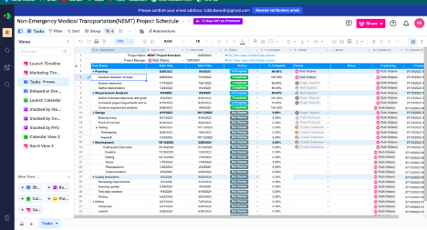

## 

## 

## **Figure 2**

## *Gantt View* *of the NEMT Project*

## 

## 

**2. 2 User Case Data Structure**

The NEMT provides different functionality to the User. As it is shown in Figure 3, using the NEMT app, user able to register, login, insert pick-up and destiny location, book a trip, call or message customer services or dispatch. Besides, user can a to leave a comment, rate the trip. On the other hand, the driver able to see the requested trip, the pickup or destiny locations ,accept or decline the trip, and track the traffic using the build-in geo-location system in the app.

**Figure 3**

*The NEMT Project User -Data Structure*  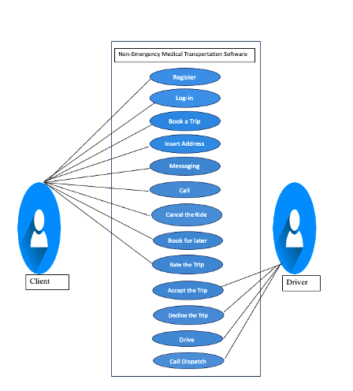

**3. Measuring and Reporting Team performance and Project Progress**

For the Agile project team measuring as well as reporting project progress and team performance are the most significant sections. Amitava Deb (2023) stated in a highly technical environment implementing standardized key indicators like the Key Performance Indicator to measure the project progress and team performance gives efficiency to the measure in terms of scope, cost, quality, schedule, risk, and performance during the software development. Trammell(2023) noted there are various KPIs metrics which are mainly categorized under Timeliness, Quality, Budget, and Effectiveness metrics. Timeliness metrics deals with completion percentage for tasks, time spent in a task, active days in working tasks ; Quality metrics measures user satisfaction, customer complaints, flaws during and the project development , Budget metrics covers budget variances , and budget iterations ; and Effectiveness metrics measures effort and resource to complete a project such as office space, salaries, and benefits. Table 2 shows the KPIs for the NEMT project according to timeliness, quality and effectiveness metrics.

For reporting progress and performance the spreadsheet.com valuable tool with different features for visualizing and reporting such as charts, sheet views, Gantt views , calendar views ,Kanban views . Open AI and spreadsheet AI makes using the platform easier by auto-generate descriptions, formulas, and calculations in creating visual reports. In addition , visualized reports of progress and performance can be shared as part of a folder or separately to team members or stakeholders(spreadsheet.com, 2023). Figure 4, 5, 6, 7 shows visual reports of NEMT team performance and project progress by using metrics described in Table 2.

**Table 2**

*KPIs Metrics for the NEMT Project*

|  |  |  |  |
| --- | --- | --- | --- |
| KPI | Description | Data needed | Reporting tool |
| Cycle Time | Measures time spent completing a task and measure the team's performance objectively. | Start date, calendar end date, duration, active hours | Donut charts |
| Cumulative flow | Visualize the status of the assigned tasks or tickets using stage names “not started”, "in progress, or “completed. | Calendar days, Duration, the number of tasks, percentage completed | Pie chart |
| Percentage of tasks completed by owner | Measures percentages of the project completed in timely manner by the owner. | Number of tasks, status of the task, owner name, calendar days, duration, active days | Bar Chart |
| Product Backlog | Refinement of backlog to prioritize tasks based on team decisions and customer requirements | Assessments, specifications, Timelines, Resources, | Line Chart |
| Overdue tasks | Indicates tasks that pass due dates. | Calendar Day, Tasks name. | Dashboard |

**3.1 Frequency and Processes of Reporting Progress and Performance**

Reporting progress and performance is important for team collaboration, tracking progress, and improving performance. In Agile projects, reports are done in standardized meetings know as Scrum meetings. Team members and managers participate in scrum meeting from the Project Manager who is responsible for designing the product, the Scrum Master who is responsible for progress tracking and team performance to the Developing team who works directly in creating the system product (Radigan, n.d.).

Osborne(2022) noted how frequently Agile meetings are held. Agile project meetings are arranged by assigning a maximum unit of time known as Sprint to a task. Based on the Sprint agile meetings encompass four types of meetings. These are Daily Scrum, Sprint Planning, Sprint Retrospective, and Sprint Review. Daily Scrum is carried out every morning, once in a day and takes up to 15 minutes and updates the project to the team. Sprint Planning is held at the beginning of Sprint and it is to make the team ready for success in the sprint. Sprit Review a 90-minute duration is done at the end of the sprint and reviews the performance of the team and the progress of the tasks in sprint. Sprint Retrospective a 90-minute duration and carried on at the end of the sprint and but aims for gathering feedback and analyzing performance and progress.

Radigan( n.d. ) also stated that in agile projects, communication with stakeholders is also arranged at the end of sprint implementing, dashboards, visual reporting charts or other tools for easy understanding. In addition, meetings are held at the beginning of the project to conduct assessments collect requirements and evaluates business intelligence of project. Launching events also be organized in the deployment stage of the project to showcase the final product to stakeholders, vendors, or end users.

**Figure 4**

*Donut Pie for Cycle Time*

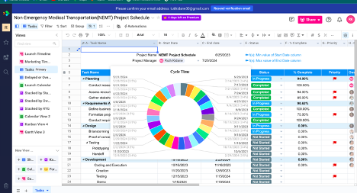

**Figure 5**

*Pie Chart for Cumulative Flow*

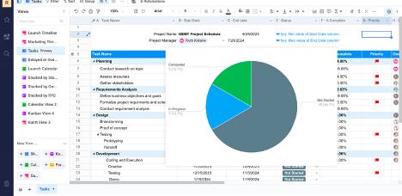

**Figure 6**

*Bar Chart* for *Percentage of Tasks Completed by the Owner* 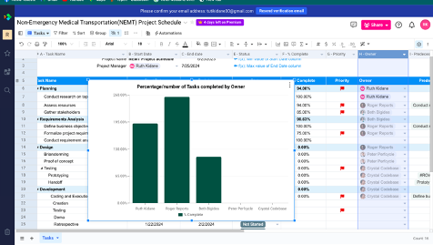

**Figure 7**

*Line Chart*  *for Prioritized Tasks* 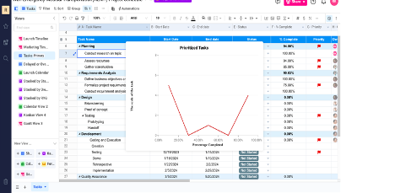

**Figure 8**

*Dashboard for Delayed Tasks*

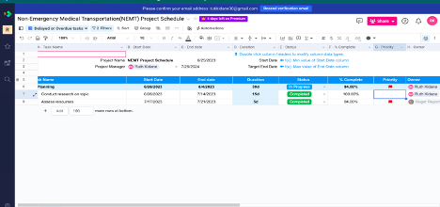

**4. Risk Reduction Strategy**

According to Blue fruit Software (2023), routinely software projects are dynamic, uncertain, and complex involve different risks that affect their scope, cost, schedule , and quality. Risks in software are the chance of encountering harm to the company, stakeholder, or end user due to intentional or unintentional activities. The damage could be finical loss, legal consequences , loss of reputation, loss of market share, project delays, and more. Risks can happen because of poor assessment and planning, lack of resources, wrong estimation, security risks, and terminations, etc. An efficient software project management have both the knowledge on risk possibilities and practical actions to identify and , analyze risks and proactively execute risk controls. Shah (2021) noted integrating risk reduction strategies helps to save time, resources, and money that could be spent for unpredicted emergency risk, builds a sound reputation, support to have a smooth and speedy project accomplishment.

DevTeam.Space(2023) explained how software risk management works best. Mostly software risk management is the assimilation of risk assessment and risk controls. Risk assessment comprises risk identification, analysis, and prioritization whereas risk controls include risk monitoring, risk management planning, and risk resolution and mitigation. To achieve both risk assessment and risk controls, specific tools are undertaken. For example, in risk assessment, we use qualitative or quantitative techniques to estimate the probability and impact of the risks. We also use risk matrices and risk registries to systematically classify and visualize the risk details.

**4. 1 NEMT Project Risk Management Risk Matrix**

Wikipedia (2023) defined a Risk matrix as a matrix in risk assessment that creates risk visibility by defining the level of the risk using the probability and impact rates of the risk.

**Table 3**

*NEMT Project Risk Management Risk Matrix*

|  |  |  |  |  |  |
| --- | --- | --- | --- | --- | --- |
| **Probability** | **Impact** | | | | |
|  | **Insignificant** | **Minor** | **Neutral** | **Major** | **Catastrophic** |
| **>90 Probability**  **Certain** | Moderate | High | Extreme | Extreme | Extreme |
| **50%-90% Probability**  **Likely** | Moderate | High | High | Extreme | Extreme |
| **10%-50% Probability**  **Moderate** | Low | Moderate | High | Extreme | Extreme |
| **3%-10% Probability**  **Unlikely** | Low | Low | Moderate | High | Extreme |
| **<3% Probability**  **Rare** | Low | Low | Moderate | High | High |

As it shown in Table 3, low or moderate risks have a chance of encountering 3% to 90% but have insignificant or minor harm. Nevertheless, high or extreme risks have huge harm but can have a 3% to 90% chance of occurrence. According monday.com(2022), insignificant risk harms can be mitigated in routine process, minor harms can cause 10% schedule delays and 10% additional budget , moderate harms lead to 30% schedule delays and 30% additional costs, major harms may cause 50 % schedule delay and 50% additional cost, and catastrophic harms can cause project termination.

**4. 2 NEMT Project Risk Management Risk Registry**

Everitt(2022) described risk registry**.** A risk register is a technique used to organize risk events, and classify risks based on their severity and assign them for management to team members. In creating risk registry, quantitative or qualitative r methods are implemented. We use qualitative assessment in creating the NEMT risk registry to measure the probability and impact with point scale of 1-5 that represents very high, high , medium, low , and very low and we rate the severity of the risk by multiplying the probability and impact number scale.

**Figure 9**

*NEMT project Risk Registry*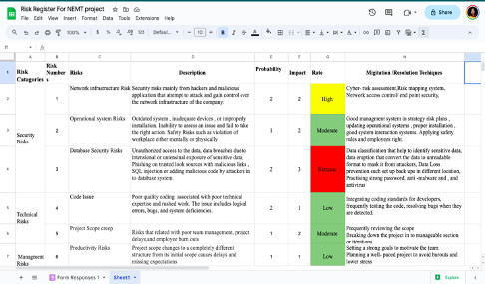

**4. 3 The NEMT Project Risks Mitigation Techniques and Legal Measures**

The NEMT Project Risks Management focus on risk assessment and controls of the security risks, technical risks, and management risks.

**4.3.1 Security Risk**

Security risks are mainly network infrastructure risks, operational system risks, and database risks. Network Security risks are predominantly malicious application from and hackers and that try to attack and capture control over the network of the company. Network risk mitigation protects network components such as routers, firewalls, switches, servers, intrusion detection systems(IDS) and domain name systems(DNS) Cyber- risk assessment , mapping system, network access control, risk security solutions like antivirus, firewall, patch managements help the security team to stay ahead of the network security attacks(VMware ,2023). According to Segal (2023) operational risks are associated with inadequate devices, outdated system or improperly installation, and inability to control an issue. Management system with high level management plans, proper installation , updated operational systems , good interaction systems, safety rules help in resolving the operational issues. Database risks associated with data breaches and unauthorized access to the data due to intentional or unintentional vulnerability of sensitive data, SQL injection by attackers into database system , and phishing on malicious links. Data classification, data eruption ,data loss prevention strong password, antimalware and , and antivirus are the valuable mitigation database risks (Imperia , 2023).

**4.3.2 Technical Risks**

Code issue and project scope creep are one of the technique risks in software projects. Poor quality coding , bugs, logical errors, and system deficiencies are the issues in software development phase. Integrating quality coding standards for developers, and quality assurances mitigations in coding problems (Indeed Editorial Team, 2023). Rarely, project scope may change to a different structure from its initial scope thus, regularly examining the scope, iterations or splitting the project into manageable portion help for creeping problems(Indeed Editorial Team, 2023).

**4.4 Legal Consideration in NEMT Project**

Software auditing and IP policy definition to the project are important legal measures in software risk management. A software audits is an internal or external inspection of a software project examines its quality, adherence plans and legal regulations. IP policy comprehend policy and procedures constructed by the software company related to usages, communication, and creating intellectual properties(IP) like trademarks, patents, trade secrets, and copyrights. IP policy must be clearly defined based on legal consultation , business goals, and engineering process that enable to be a safeguard to the system product originality and business growth (Hassin, 2010).

**5. IT Support program in the Healthcare Technology Company**

Technological evolution has revolutionized user experiences by carrying out seamless and consistent services over the companies’ platforms. Kidd (2019) discusses IT support in improving user experiences, and IT staff efficiency to use resources and time in resolving user issues. IT support is also known as technical support or Service Desk, a contact point for solving user problems and a bridge that connects the company and user. Companies with authentic, friendly, fast and supportive service desks have recorded as a higher reputation, customer satisfaction, and business scalability. According to Buchanan(2023) Service desk or IT support is important for being IT requests, incident management, proactive problem solving, and trustable reporting center . The fundamental of Service desk or IT support is the performance of the five IT support levels. These are level 0, level 1, level 2, level 3, and level 4 IT support.

**5.1 IT Support -Level 0**

Level 0 is a technology driven services or self-services for solving minor user issues by following visual or written instructions.level-0 IT support provides a self-service portal to register user issues, service catalog to direct to service information, a knowledge base articles on how-to information, and help-sections. Minor issues such as log-in issues, change password, and easy usages of software and hardware components, are carried on in the zero level. This level has a valuable role in reducing the wasting time of qualified expertise on answering to every user request over the phone ( Nazari, 2022).

**5.2 IT Support-Level 1**

Hertvik (n.d.) noted IT support level-1 is where the technical support begins in a directly contact with the support team. Level 1 is known by person-to person first line contact to solve issues that self-service cannot solve. Level-1solves IT routine cases and issues that level 0 cannot resolve. The responsibilities of level-1 stuff includes user account management, end user technical support, proactive incident management, issue resolution and documentation, troubleshooting, and system installation and updates. Level-1 support team have both technical and non-technical skills. Soft skill like communication skills and customer service are typical to level-1 IT support stuff for they are responsible effectively communicate and clearly understands user issues. Level 1 team analyze the issue and provide an IT solution and if the issues require extra technical assistance , the team will escalate the issue to level-2 IT support stuff.

**5.3 IT Support-Level 2**

Danby(2023) mentioned the IT support level-2 is the main actor in the IT five model support. It involves complex IT incidents that could not be solved in previous level, develop technical based articles, documenting mitigation techniques , and contacting or visiting the customer if it required. The level-2 IT support team is equipped with high level IT skills who to troubleshoot deeper and solve problems with informed anticipations.

**5.4 IT Support-Level 3**

Level 3 is the top technical level support in the five model IT support. Mottesi(2023) discussed level 3 IT support has greater quality resources and permissions to design, engineer, and maintain multilevel IT issues. The level 3 IT stuff analyze user needs and support streams to certify tickets are properly scaled, develop improvement programs , troubleshoot issues in detail , develop knowledge-based guidelines, communicate stakeholders for common solutions, and document resolution procedures.

**5.5 IT Support- Level -4**

Level 4 is the final and external IT support level for the complex issues that previous IT desk levels unable to solve. Level-4 IT support aims to manage and resolve complex incidents effectively by utilizing IT outsourcing. Outsourcing is a technique of replacing inner IT resource of a company with external IT resources for issue mitigation and technical consultation. The level 4 IT desk is responsible in solving issues that level 1,2, and 3 IT support levels could not solve(Aranda ,2022).

**Conclusion**

In today's dynamic IT world, creating a good quality system solution requires a coordination of human,  technical, and behavioral skills, and efficient usage of resources. Understanding this, the NEMT software project team conscientiously constructed its project plan, documenting knowledge-based work procedures, preparing its members with all technical and soft skills, and assembling the right methodologies and tools to develop the proposed solution. The NEMT team started its project by conducting business assessment, requirements specification, and analyzing the requirement using a popular strategic plan SWOT analysis. This helps to have a clear understanding on the business goals , user requirements, and determine what to improve and continue to work. By implementing the Software Development Life Cycle(SDLC) the team able to organize its  work plans, and sketch timelines and required resources in the spreadsheet.com tool. Additionally, KPI technique is integrated to measure project progress and team performance using carefully studied metrics and communication progress and performance reports has been achieved through Scrum meetings . Furthermore, risk reduction strategies are incorporated to proactively response the inevitable risks during the project using software risk management methods and tools such as qualitative risk assessment, risk matrix , and risk registry. At last, IT support services is coordinated as part of project to ensure there will be a continuous connection between the user and the company to solve any simple to multi-level user issues.

**Reference**

Addevice. (2023, June 3). *How to Make an App Like Uber: Features and Tech Details.* Addevice. https://www.addevice.io/blog/how-to-make-an-app-like-uber

Alameri, H. (2022). *Top Management Support.* LinkedIn. https://ae.linkedin.com/in/drhusamalameri?trk=article-ssr-frontend-pulse_publisher-author-card

Amitava, D. (2023). *What are the key performance indicators (KPIs) for software project management?* LinkedIn. https://www.linkedin.com/advice/0/what-key-performance-indicators-kpis#

Aranda, H. (2022, November 23). *Should I Outsource my IT? Pros, Cons, and Things to Consider*. Invgate blogs. https://blog.invgate.com/outsource-it

AWS. (2023). *What Is SDLC (Software Development Lifecycle)?* AWS. https://aws.amazon.com/what-is/sdlc/

Blankley, B. (2018, August 21). *Colorado is seventh best state for health care*. Watchdog.org. https://www.thecentersquare.com/colorado/

Buchanan BT. (2022). *What are the Different Tiers of IT Support*. Buchanan BT. https://www.buchanan.com/what-is-the-difference-between-it-support-tiers/

Burak, A. (2023, May 23). *Agile Software Development Team Structure*. Relevant. https://relevant.software/blog/what-agile-software-development-team-structure-looks-like/

CCHA. (n.d.). *Transportation*. CCHA. https://www.cchacares.com/for-members/transportation

Coursera, C. (2023, June 16). *What Is the Software Development Life Cycle? SDLC Explained*. Coursera. https://www.coursera.org/articles/software-development-life-cycle

Danby , S. (2023, January 5). *The Basics of Tier 2 Help Desk*. Invgate blogs. https://blog.invgate.com/tier-2-help-desk

Fingent. (n.d.). *Top Technologies Used to Develop Mobile Apps*. Fingent. https://www.fingent.com/blog/top-technologies-used-to-develop-mobile-app

Haidari, R. (2023, May 24). *Agile Reporting: How to Streamline Data Collection and Reporting for Your Team*. Go Retro. https://www.goretro.ai/post/agile-reporting

Harrin, E. (2022, September 8). *Why are people leaving project management?* RGPM. https://rebelsguidetopm.com/why-are-people-leaving-project-management/

Hertvik, J. (2019, April 25). *L1, L2, L3 & More*. bmc blogs . https://www.bmc.com/blogs/support-levels-level-1-level-2-level-3/

Indeed Editorial Team. (2023, March 10). *12 Risks in Software Development*. Indeed. https://www.indeed.com/career-advice/career-development/risks-in-software-development

Interaction Design Foundation. (2023). *Brainstorming*. Interaction Design Foundation. https://www.interaction-design.org/literature/topics/brainstorming

Kidd, C. (2019, April 25). *IT Support Levels Clearly Explained: L1, L2, L3 & More*. bmc blogs . https://www.bmc.com/blogs/support-levels-level-1-level-2-level-3/

Modivcare. (2023a). *How it works*. Modivcare. https://www.mymodivcare.com/how-it-works

Modivcare. (2023b). *Non-Emergency Medical Transportation*. Modivcare. https://www.modivcare.com/offerings/nemt

Mottesi, C. (2023, February 3). *The 5 Levels of IT Support: Leveraging Your Help Desk Support with Tiers 0 to 4*. Invgate. https://blog.invgate.com/the-5-levels-of-it-support

Nandaniya, H. (2022, October 3). *How To Build an App Like Uber - Step-by-Step Guide*. Maruti techlabs. https://marutitech.com/build-an-app-like-uber/

Nazari , H. (2022, May 12). *IT Support Levels: Level 1, Level 2, Level 3 Tech Support*. Geniuses. https://geniusee.com/single-blog/it-support-levels

Osborne, K. (15AD). *Agile Meetings 101, How to conduct them properly*. Nifty. https://niftypm.com/blog/agile-meetings-

Radigan, D. (n.d.). *An agile guide to scrum meetings*. Atlassian. https://www.atlassian.com/agile/scrum/ceremonies

Rouse, M. (2015, August 20). *Support Level*. Technopedia. https://www.techopedia.com/definition/25809/support-level#

Segal, T. (2023). *Operational Risk Overview, Importance, and Examples*. Investopedia. https://www.investopedia.com/terms/o/operational_risk.asp#:~:text=Operational%20risk%20is%20usually%20caused,%2C%20systems%2C%20or%20external%20events

Shah, K. (2021). *Risk Management in Software Development: A Complete Guide*. Thirdrocktechkno. https://www.thirdrocktechkno.com/blog/risk-management-in-software-development-a-complete-guide/

The spreadsheet. com. (2023). *The #1 Smartsheet alternative for Project Management and custom apps.* spreedsheet.com. https://www.spreadsheet.com/compare/smartsheet-alternative

Trammell, H. (2023, April 4). *28 Important Project Management KPIs (& How To Track Them)*. Clear Point Strategy. https://www.clearpointstrategy.com/blog/important-project-management-kpis

Vaghela, P. (2023, April 7). *A Comprehensive Guide to Healthcare Software Development In 2023*. Big Scal. https://www.bigscal.com/blogs/healthcare-industry/guide-to-healthcare-s

Wikipedia. (2023). *SWOT analysis*. Wikipedia. https://en.wikipedia.org/wiki/SWOT_analysis